NORFOLK COUNTY CRICKET CLUB 200 CLUB

Thank you for your interest in becoming a Member of the 200 Club.

Draws are held on a monthly basis – 10 months of two prizes - £50.00 and £25.00 plus August and December having five prizes - £250.00, £125.00, £75.00, £50.00 and £25.00.

YES / NO You may pay by BACS to Norfolk County Cricket Club 200 Club, Sort Code 60-15-31, Account no. 68199511

YES / NO You may pay by cheque – payable to Norfolk County Cricket Club 200 Club. See below for return address.

YES / NO You may pay by Standing Order. A sum of £13.00 is collected quarterly from your Bank/Building Society on the first day of January, April, July and October each year on an ongoing basis.
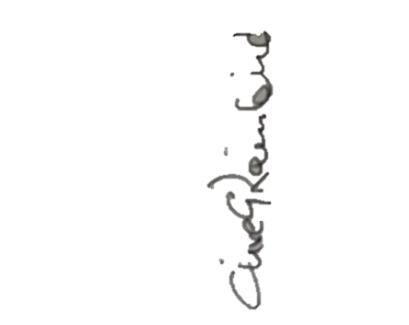
Please can you complete the Standing Order Mandate outlined below and return for my attention.

Yours sincerely,

Clive Rainbird - Norfolk County Cricket Club 200 Club administrator

Clive Rainbird, 14 Sidney Bunn Way, Drayton, Norwich, NR8 6BQ
or e-mail to – cgrainbird@icloud.com
Mobile no: – 07971 119950

NORFOLK COUNTY CRICKET CLUB 200 CLUB

Standing Order Mandate

Name (Block capitals please) ……………………………………………………………… Tel no. ………………………….

Address ……………………………………………………………………………………………… Post Code ……………………..

Email: ……………………………………………………….

To your Bank ………………………………………………….. Account name……………………………………………………

Bank Address……………………………………………………………………………………….. Post Code ……………………..

Sort Code ……………….. Account number …………………………..

Please pay to NatWest Bank Plc, Norwich City Office, Norfolk County Cricket Club 200 Club, Sort Code 60-15-31, Account no. 68199511 the sum of £13.00 quarterly on the first day of January, April, July and October each year until further notice. Please state which month ……………………….

Signature……………………………………………………… Date……………………………

Please complete and return to: –
Clive Rainbird, 14 Sidney Bunn Way, Drayton, Norwich, NR8 6BQ
or e-mail to – cgrainbird@icloud.com
Mobile no: – 07971 119950

